

**Faculty of Engineering & Technology - B.Tech**

| **Name** | **Enrollment Number** |
| --- | --- |
| Hard Pansara | 202202626010074 |
| Vimal Parmar | 202202626010075 |
| Aaditya Thacker | 202202626010095 |
| Aalok Shah | 202202626010085 |

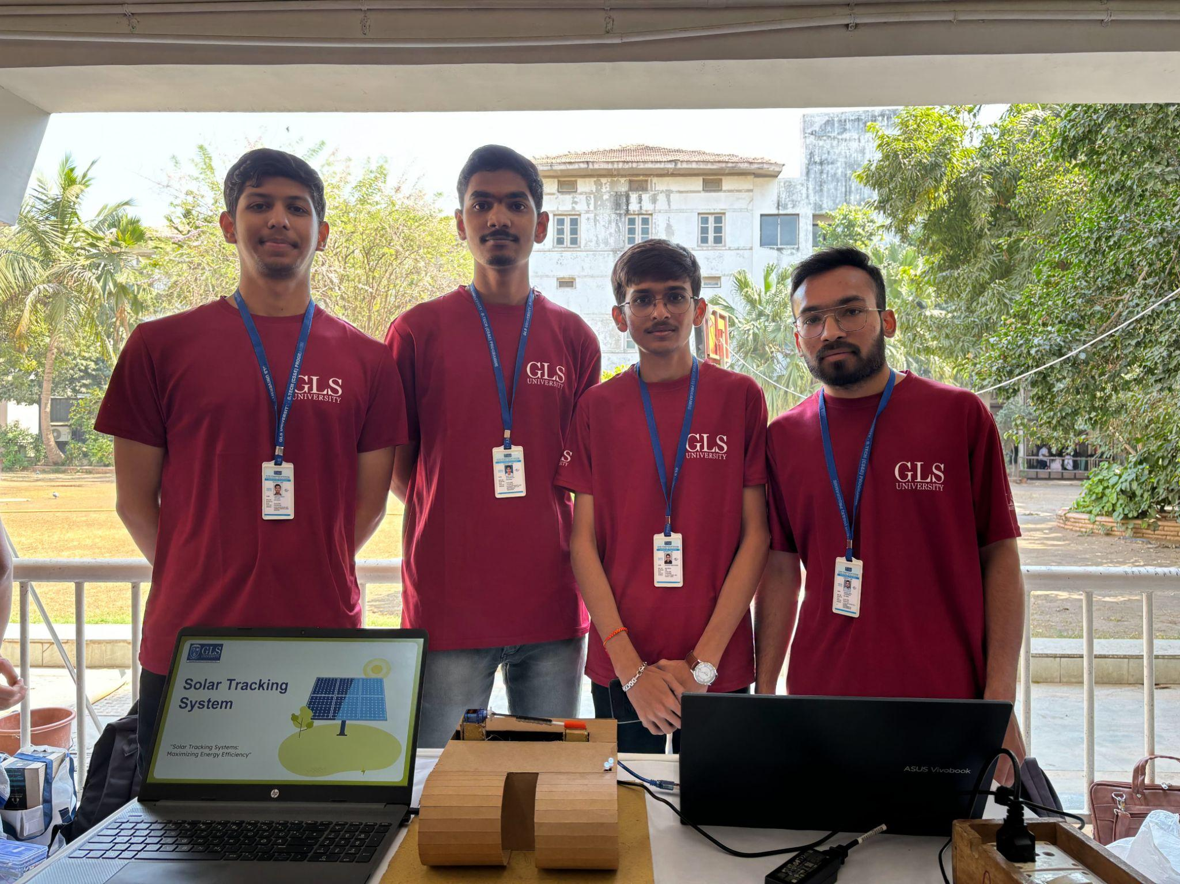

**Index**

* Introduction
* Primary Goal
* Component Used
* Components Description
* Advantages
* Disadvantages
* Challenges
* Why we should use Solar Tracking System
* Conclusion

**Introduction**

Solar tracking systems represent a sophisticated technology designed to dynamically align solar panels with the ever-changing movement of the sun. This innovative approach is aimed at optimizing the absorption of solar energy, thereby significantly enhancing the overall efficiency of photovoltaic systems. The fundamental principle behind solar tracking involves ensuring that solar panels continually face the sun, allowing for a maximized exposure to sunlight throughout the day.

By employing solar tracking technology, the efficiency of photovoltaic systems is substantially increased, resulting in a heightened output of renewable energy. This dynamic alignment with the sun's trajectory enables solar panels to capture sunlight more effectively, thus enhancing the overall performance of solar energy systems. The continuous adjustment of the panels to follow the sun's path in the sky ensures that the incident sunlight is consistently harnessed, contributing to a more sustainable and effective energy solution.

**Primary Goal**

A solar tracking system is an innovative and advanced technology meticulously crafted with the primary objective of significantly enhancing the efficiency of solar energy collection. This cutting-edge system achieves its goal by intelligently orienting solar panels or mirrors to seamlessly follow the sun's trajectory across the sky.

The essence of this technology lies in its dynamic adjustment mechanism, which meticulously optimizes the angle of incidence between the solar modules and the incident sunlight. By continuously aligning the solar panels or mirrors with the sun's path, this solar tracking system ensures that these photovoltaic elements receive the maximum possible sunlight exposure throughout the entire day.

This constant and precise alignment is pivotal in the quest for optimal solar energy absorption. The solar tracking system's ability to adapt to the sun's movement guarantees that solar modules are consistently positioned at the most advantageous angle, maximizing the absorption of sunlight and, consequently, enhancing the overall efficiency of the solar energy collection process.

In essence, a solar tracking system represents a groundbreaking solution designed not only to increase the efficiency of solar energy harvesting but also to do so in a sophisticated and dynamic manner. By harnessing the power of continuous alignment with the sun's path, this technology ensures that solar panels or mirrors are always in an ideal position to capture the abundant solar energy available throughout the day.

**Component Used**

* Arduino UNO
* Jumper wire
* Breadboard
* Led
* LDR sensor
* Servo Motor
* Solar Panel
* USB cable

**Compenents Description**

* Arduino UNO:

The Arduino UNO is a versatile microcontroller board that serves as the brains of your electronic projects. It features input and output pins, a USB connection for programming, and is compatible with a wide range of sensors and modules. With its user-friendly interface and open-source nature, the Arduino UNO is an ideal choice for beginners and experienced makers alike, enabling the creation of interactive and programmable devices.

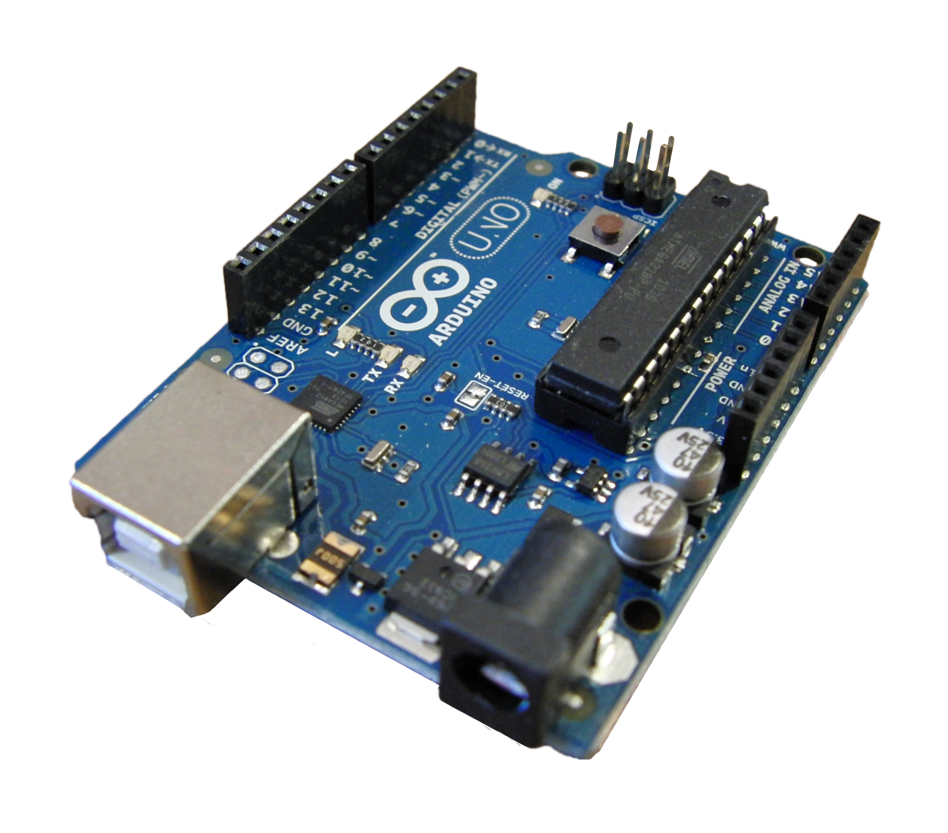

* Jumper Wire:

Jumper wires are essential components for connecting various elements on a breadboard or between different modules in an electronics project. These flexible and easily pluggable wires allow for the seamless transfer of signals and power between components, providing a neat and organized way to establish electrical connections without the need for soldering.

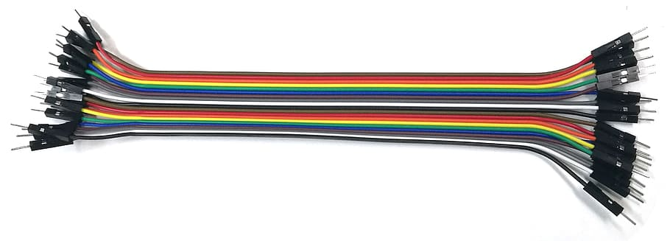

* Breadboard:

A breadboard is a prototyping tool used to create and test electronic circuits without soldering. It consists of a grid of interconnected holes where components can be inserted and connected using jumper wires. Breadboards are invaluable for experimenting with circuit designs, making them an indispensable tool for electronics enthusiasts and students.

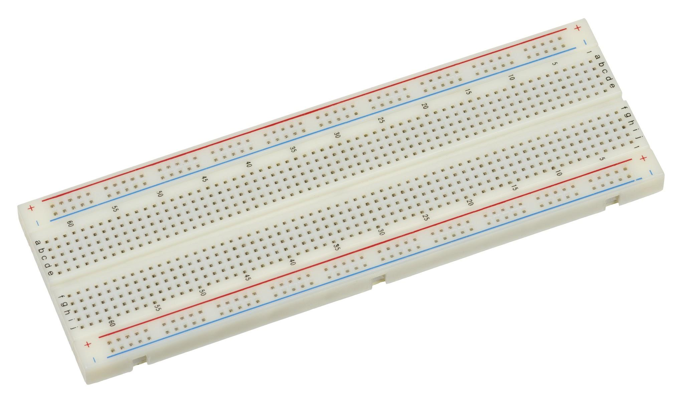

* LED (Light-Emitting Diode):

Light-emitting diodes, or LEDs, are semiconductor devices that emit light when an electric current passes through them. In electronic projects, LEDs are commonly used as indicators, visual alerts, or to provide illumination. They come in various colors and sizes, making them versatile components for adding visual feedback to your circuits.

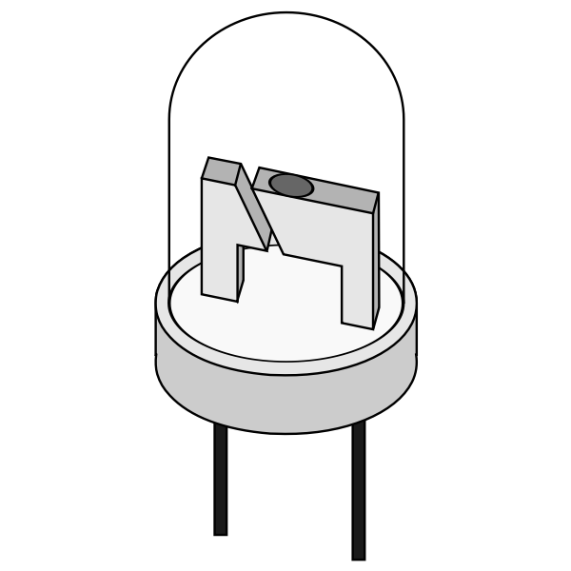

* LDR (Light-Dependent Resistor) Sensor:

An LDR sensor, or photoresistor, changes its resistance based on the intensity of light it receives. This makes it a valuable component for detecting ambient light levels in electronic projects, such as automatic lighting systems or sun-tracking mechanisms. LDRs are particularly useful for applications where the device's behavior should adapt to varying light conditions.

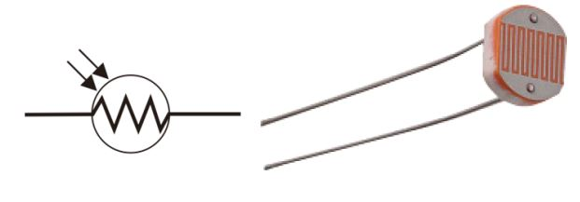

* Servo Motor:

A servo motor is a rotary actuator that precisely controls the angular position of its output shaft. It is commonly used in projects requiring controlled and precise movement, such as robotics, remote-controlled vehicles, or mechanisms like solar panel tracking systems. Servo motors are known for their ability to maintain a set position and respond to control signals accurately.

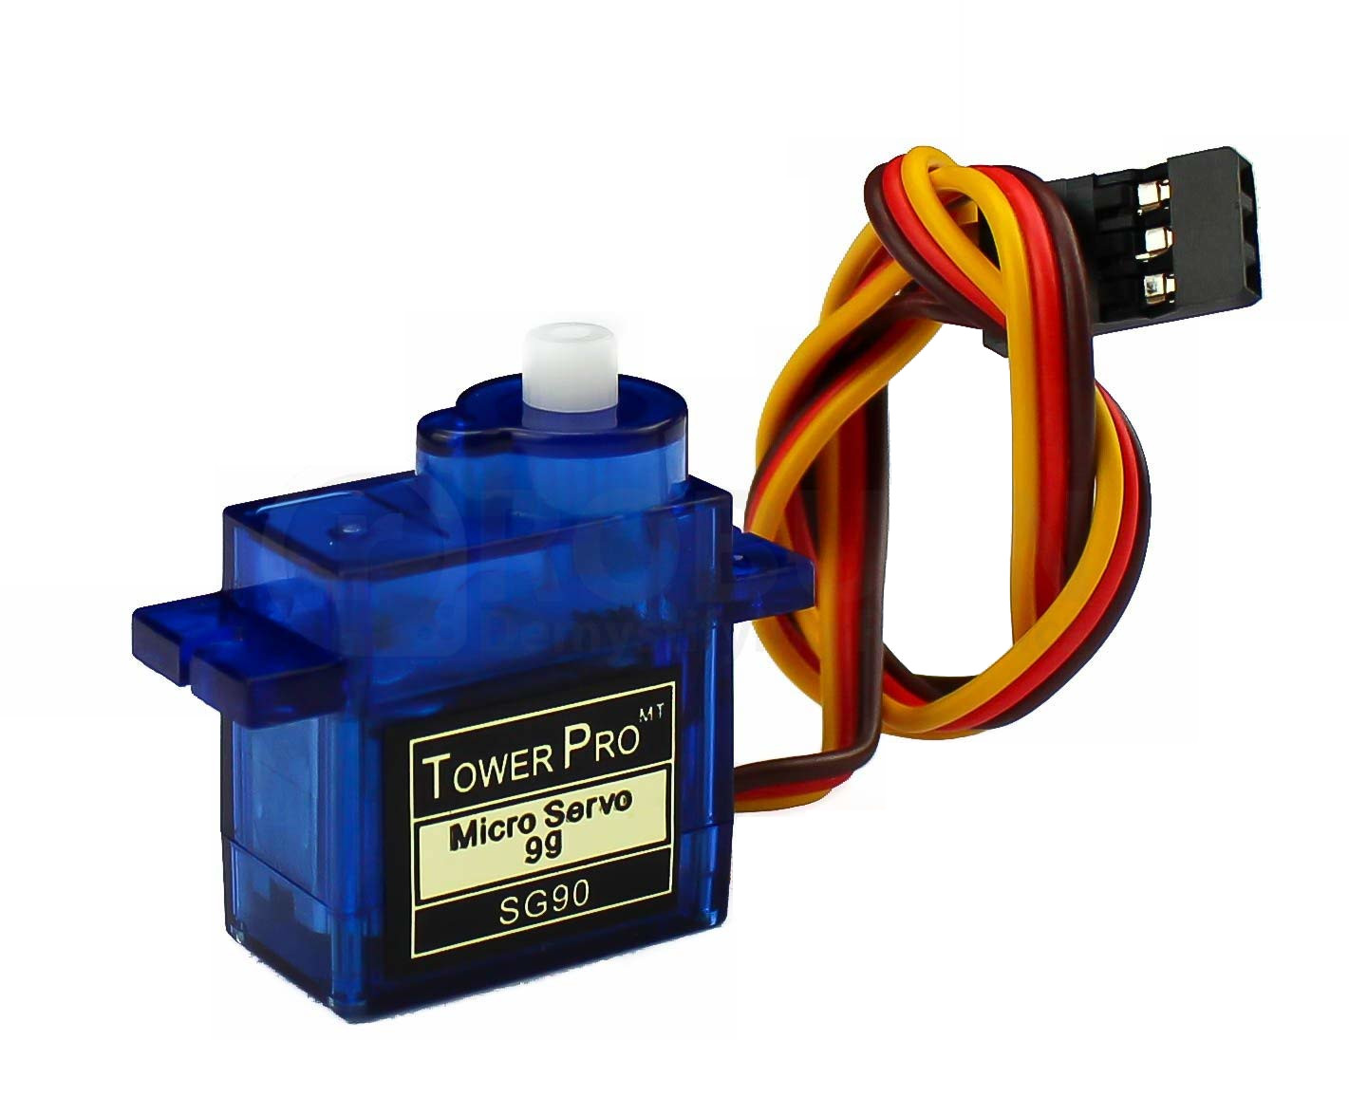

* Solar Panel:

A solar panel converts sunlight into electrical energy using photovoltaic cells. In electronic projects, solar panels serve as sustainable and renewable power sources, providing a clean energy option for charging batteries or powering low-energy devices. Their efficiency in harnessing solar energy makes them crucial components in projects focused on environmentally friendly power solutions.

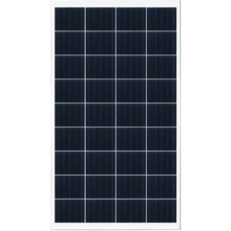

* USB Cable:

A USB cable serves as the interface between the Arduino UNO board and a computer for programming and power. The USB connection enables data transfer, allowing users to upload code to the Arduino and power the board simultaneously. USB cables with Type-A and Type-B connectors are commonly used in Arduino projects, ensuring seamless connectivity and communication.

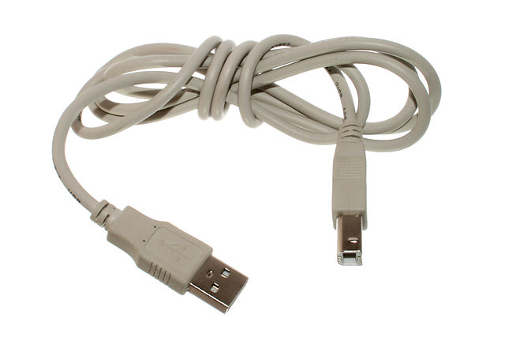

**Advantages**

1. Increased Energy Output:

Solar panels are meticulously optimized to harness the maximum sunlight, thereby significantly enhancing energy absorption and, consequently, boosting overall energy output. This optimization ensures that solar panels operate at their peak efficiency, contributing to a more sustainable and robust renewable energy solution.

1. Extended Operational Hours:

By intelligently aligning with the sun's trajectory from sunrise to sunset, solar panels in a solar tracking system extend their operational hours. This prolonged exposure to sunlight not only enhances the overall power generation capacity but also ensures that energy is continuously harvested throughout daylight hours, maximizing the system's operational effectiveness.

1. Improved Efficiency:

The dynamic adjustment of solar panels to remain perpendicular to the sun's path is a key factor in the improved efficiency of a solar tracking system. This constant alignment optimizes the angle of incidence, promoting more effective energy conversion and, consequently, enhancing the overall efficiency of the photovoltaic system.

1. Economic Benefits:

The enhanced energy production achieved through solar tracking systems translates into substantial economic benefits. Higher energy yields contribute to better returns on investment over the system's lifespan, making it a financially viable and attractive option for those seeking sustainable energy solutions with long-term economic advantages. The economic benefits extend beyond mere energy production, positioning solar tracking systems as a prudent and economically sound investment in the renewable energy landscape.

**Disadvantages**

1. Higher Initial Cost:

Active solar tracking systems, while offering superior benefits, often incur a higher upfront cost compared to their fixed counterparts. This increased initial investment is attributed to the sophisticated technology and mechanisms involved in actively aligning solar panels with the sun's movement, contributing to a more substantial but potentially more rewarding financial commitment in the long run.

1. Maintenance Challenges:

Active solar tracking systems, featuring moving parts for optimal alignment, may pose challenges related to regular maintenance. The dynamic nature of these systems requires attention to moving components, ensuring they operate smoothly over time. While maintenance is crucial for preserving system functionality, it adds an aspect of ongoing care that needs to be considered when adopting active solar tracking technology.

1. Environmental Impact:

The efficiency of active solar tracking systems may be susceptible to adverse weather conditions, impacting both system efficiency and durability. Factors such as cloud cover, rain, or other environmental challenges can temporarily reduce the effectiveness of solar tracking, highlighting the need for robust system design and adaptation to diverse weather conditions. A thorough consideration of the local climate and environmental factors is essential to mitigate potential challenges associated with system performance.

Despite these challenges, it's important to recognize that active solar tracking systems, with their higher initial cost and maintenance requirements, offer significant advantages in terms of increased energy output and efficiency. The decision to invest in such systems involves weighing the initial financial commitment against the long-term benefits they bring to renewable energy generation.

**Challenges**

1. Complexity of Installation:

The implementation of active solar tracking systems often involves a higher level of complexity during installation. Unlike fixed installations, the dynamic nature of active tracking requires meticulous alignment and calibration, potentially necessitating professional expertise for accurate setup. This increased complexity emphasizes the importance of skilled installation to ensure optimal system performance.

1. Power Consumption:

Active solar tracking systems, being more sophisticated in their design, may incur additional power consumption compared to fixed installations. The energy needed to operate the tracking mechanisms, sensors, and control systems contributes to a higher overall power demand. While the increased energy output offsets this factor, it's essential to consider the power consumption aspect as part of the overall system dynamics and efficiency.

1. Geographical Limitations:

The suitability of active solar tracking systems is contingent upon specific geographical factors, sunlight availability, and local environmental conditions. Certain locations may experience limited sunlight exposure due to factors like cloud cover or shading, affecting the overall effectiveness of active tracking systems. Understanding the geographical limitations and ensuring compatibility with local conditions is crucial when considering the deployment of such advanced solar technologies.

**Circuit Diagram and Code**

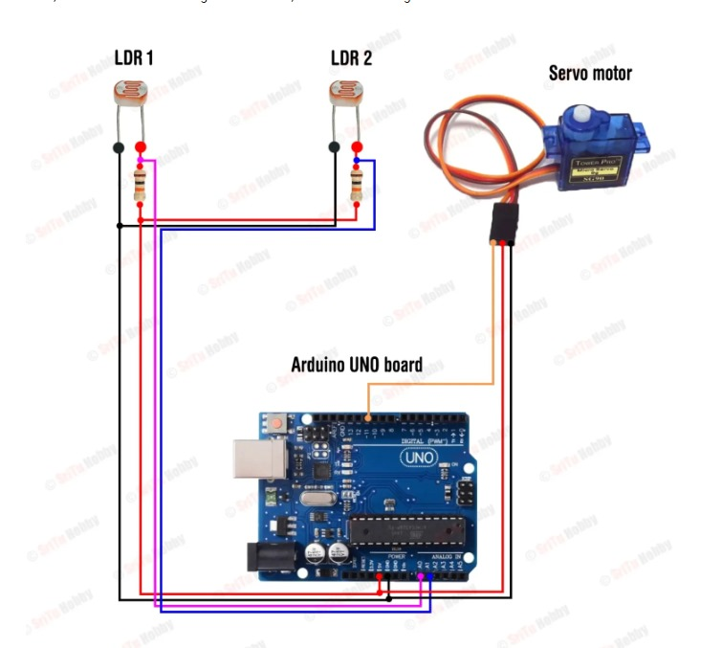

**Code**

//Include the servo motor library

#include <Servo.h>

//Define the LDR sensor pins

#define LDR1 A0

#define LDR2 A1

//Define the error value. You can change it as you like

#define error 10

//Starting point of the servo motor

int Spoint = 90;

//Create an object for the servo motor

Servo servo;

void setup() {

//Include servo motor PWM pin

servo.attach(11);

//Set the starting point of the servo

servo.write(Spoint);

delay(1000);

}

void loop() {

//Get the LDR sensor value

int ldr1 = analogRead(LDR1);

//Get the LDR sensor value

int ldr2 = analogRead(LDR2);

//Get the difference of these values

int value1 = abs(ldr1 - ldr2);

int value2 = abs(ldr2 - ldr1);

//Check these values using a IF condition

if ((value1 <= error) || (value2 <= error)) {

} else {

if (ldr1 > ldr2) {

Spoint = --Spoint;

}

if (ldr1 < ldr2) {

Spoint = ++Spoint;

}

}

//Write values on the servo motor

servo.write(Spoint);

delay(10);

}

**Project Photos**